National University of Computer and Emerging Sciences, Karachi
Spring-2022, FAST School of Computing
Re-Final Examination
June 29, 2022, 9:30 am – 12:30 am
Course Code: CS3001 | Course Name: Computer Networks
Instructor Name: Dr. Farrukh Salim , Dr. Aqsa Aslam, Mr. Shoaib Raza and Ms. Eman Shahid
Student Roll No: | Section:

Instructions:
- Return the question paper. Do not write anything on question paper, except your Roll # & Section #.
- Read each question completely before answering it. There are 10 questions and 4 pages.
- In case of any ambiguity, you may make assumptions. However, your assumptions should not contradict any statement in the question paper.
- All the answers must be solved according to the sequence given in the question paper.
- This paper is subjective. Write the answers only on answer sheet.

Time: 180 minutes. Max Points: 100

Question 1: CLO-01 [5x2=10 points]
Consider the scenario shown below in Figure 1, in which Alice sends an email to Bob. Assume both Bob's and Alice's user agents use the HTTP protocol.
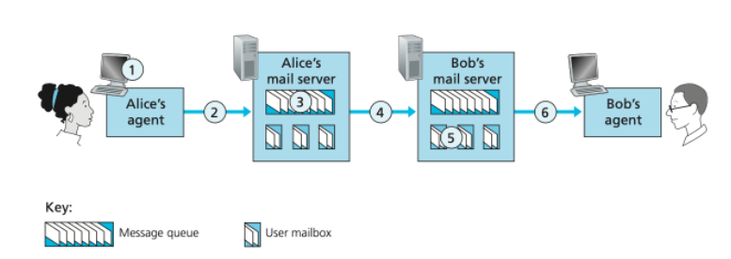
Figure 1. Email communication paradigm

- At point 2 in the diagram, what protocol is being used?
- At point 4 in the diagram, what protocol is being used?
- At point 6 in the diagram, what protocol is being used?
- Is SMTP a 'push' or 'pull' protocol?
- Is HTTP a 'push' or 'pull' protocol?

Question 2: CLO-01 [2x5=10 points]
- Suppose you have just created an exciting new startup company called Network Utopia. You have to register the domain name at the registrar. Provide names, IP addresses of authoritative name server (primary and secondary) and write DNS Records that the registrar would insert into the DNS system. Suppose the IP address over which the domain is hosted is 212.212.212.1.

- Consider the network n Figure 2. With the indicated link costs, use Dijkstra’s shortest-path algorithm to compute the shortest path from x to all network nodes. Find the least cost path tree from source node x to all other destinations. Show how the algorithm works by computing a table.

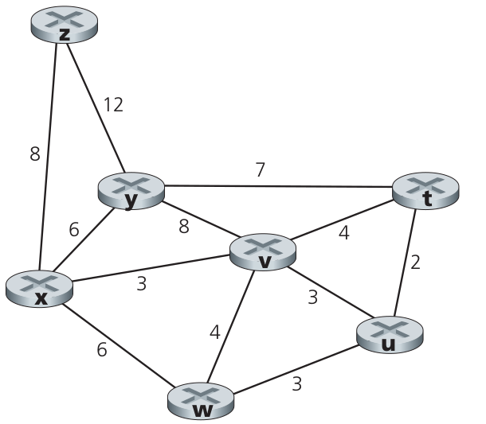
Figure 2. A network graph

Question 3: CLO-01 [10 points]
Write down the steps of how BGP will advertise the reachability information for prefix x to all of the routers as shown in Figure 3.

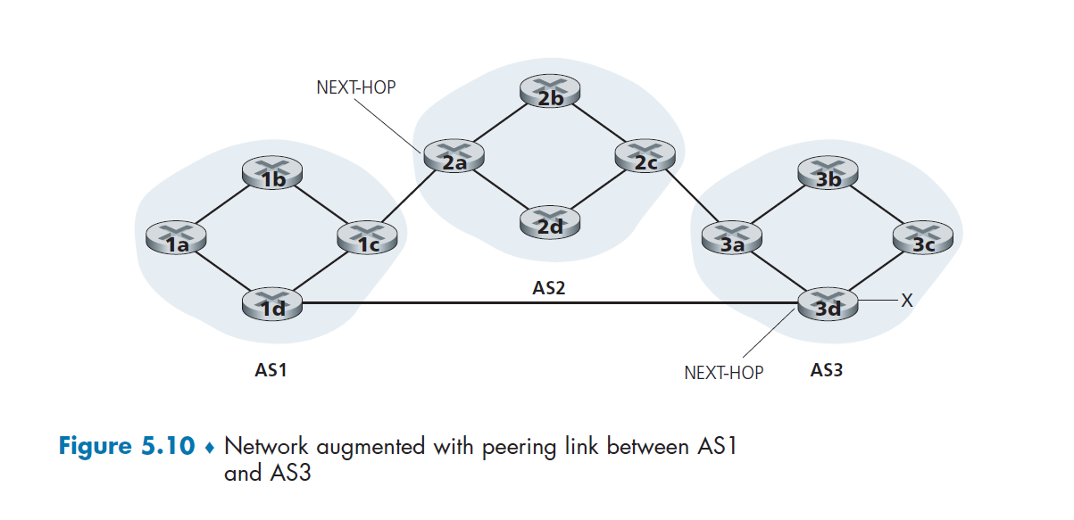
Figure 3. A network consisting of different Autonomous Systems

Question 4: CLO-01 [5x2=10 points]
Write the difference, in maximum 30 words each (answer will not be marked after 30 words)
a) Software Defined Network versus Network Function Virtualization
b) Length field of TCP Header versus the Length field of IPv4 Header
c) Checksum Field of UDP Header versus the Header Checksum Field of IPv4 Header
d) Forwarding versus Routing
e) Speed of convergence of Link State versus Distance Vector

Question 5: CLO-02 [3 + 4 +3 = 10 points]
- In network-assisted congestion control, how is congestion in the network signaled to the sender?
- In end-end congestion control, how is congestion in the network signaled to the sender?
- Name one protocol that uses an end-end congestion approach?

Question 6: CLO-03 [5+5 = 10 points]

a) Consider an application that uses rdt 3.0 as its transport layer protocol, which is a reliable, error-correcting stop and wait protocol. Assume that the sender sends two packets with sequence numbers 0 (pkt0) and 1 (pkt1). Among them, a packet with sequence number 1 is lost. Demonstrate with the help of a sequence diagram how rdt 3.0 recovers from that packet loss?
b) Suppose a packet is 10K bits long, the channel transmission rate connecting a sender and receiver is 10 Mbps, and the round-trip propagation delay is 10ms. What is the maximum channel utilization of a stop-and-wait protocol for this channel?

Question 7: CLO-03 [3 + 4 +3 = 10 points]
Consider there is only one router, with finite buffer capacity. The input and output link capacity of router is R. Two flows are attached to the router, each flow sharing half of the router capacity and each flow have:

(i) The perfect knowledge of the router buffer capacity.
(ii) Have partial knowledge, and knows only if the packet is dropped at the router (retransmission needed for lost packet).
(iii) Have no knowledge about router buffer, nor about any dropped packet (guess only by acknowledgement packets).

Plot the graphs for each of the above case for only one flow, showing transport-layer input on x-axis and maximum achievable receiver throughput at y-axis.

Question 8: CLO-03 [4x2.5 = 10 points]
SDN provides a programmable control plane, however, it network infrastructure needs changes as we studied in chapter # 5 of our textbook. Now, answer the following questions.
- How the data plane is different while using SDN? Explain.
- What is the key role of OpenFlow in SDN?
- Setup a flow table entry which prefers traffic from an IP telephone. Make suitable assumptions.
- How SDN controller (explain in a step-by-step way) make use of different network application to provide link state routing in the SND setup? Explain.

Question 9: CLO-03 [4+3+3=10 points]
Consider a two LAN connected by a router as shown in Figure 4.

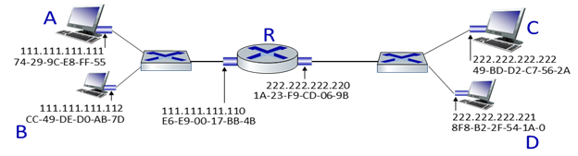
Figure 4: A Network Topology
- Host A transmits a packet to host D. Which Layer 2 and Layer 3 addresses are contained in the protocol data units that are transmitted from host B to the router?
- Host A wants to get the MAC address of Host C, which protocol Host A will use to find the C’s MAC address? What is the purpose of that protocol?
- Host B issues an ARP request because it want to send a packet to Host D. what will happen next?

Question 10: CLO-03 [10 points]
Because of the connection-oriented nature of TCP, a connection setup phase is required at the beginning of each session, as well as a connection tear-down phase at the end of the session. Enumerate the events below in the order they occur as host A opens a TCP connection to host B, transmits data and then closes the connection. Write a 1 next to the event that occurs first and continue like that until all occurring events are enumerated (the first event has been enumerated for you). You may assume that no segments are lost. Also indicate at which host the event happens. Please note that there might be events listed below that are not a part of the above data transfer and hence should not be enumerated.

Event | Host | Order
Send an ACK segment
Do the rest of the data exchange
Close the connection
Send an ACK segment
Send a FIN segment
Send a SYN segment | A | 1
Send a FIN segment
Send a RST segment
Send a SYN-ACK segment
Enter the TIME-WAIT state
Send an ACK+DATA segment
Close the connection

BEST OF LUCK!

